**Technical Proposal**

|  |  |
| --- | --- |
| Company Name | InnovAccer Management Private Limited |
| Registered Address | C-110, Shivalik, Malviya Nagar, New Delhi, India |
| Areas of Operation | Technology, Data Analysis, Data Visualization |
| Project | Proposal for development of a web-based, interactive, and user-friendly application for use by the Abdul Latif Jameel Poverty Action Lab (JPAL). |

# Introduction

Technical Proposal details application architecture, approach, flexibility within architecture, and support & services to provide a holistic suite of intuitive, flexible, and scalable application suite for JPAL.

Table of Contents

Introduction 2

Objective 3

Application Architecture 3

Components 5

Access Control 5

Database Handler 5

Web UI Layer 5

Mobile Back-End /Mobile API Endpoint 5

Data Sync Handler 5

Mobile UI Layer 6

USE-CASE DIAGRAM 7

Support & Services 11

Ongoing Support 11

Fresh Support 11

Staffing 12

Timelines 13

Few Examples of InnovAccer designed intuitive platforms and dashboards 14

# Objective

JPAL requires a cloud-based technology platform to collect, store, organize, protect and access data for collecting survey data on micro and small enterprises in developing countries.

# Application Architecture

A multi-layer architecture is proposed below wherein customization for a particular layer will not require changing codes in other layers. Also, end users at JPAL will not get affected with any modification to the back end architecture.

A back-end infrastructure is proposed to be handled on web with a Google Cloud SQL data support. Google Cloud SQL services are flexible (most of the features can be changed via coding interface) and scalable (any amount of data can be handled).

There will be two front-end layers for mobile and web. Multi-layer structure in front-end layer provides administrator with customization on survey screens and handle various sorts of view-ability and workability options as described in the components below.

To summarize, the application architecture is illustrated in the diagram below. Main features of proposing this architecture are:

1. **Modularity in architecture**: Additions or improvisation on a particular module does not need whole code to be changed but only a sub-module of that particular module. Also testing becomes easier as bugs in each module can be tracked individually rather than in the whole piece of code.
2. **Scalability and Response Time**: Largeness of Data will not act as a hurdle in successful implementation and running. Neither will issues like higher response times, hanging website, or unhappy customers with this architecture because Google Cloud SQL is built on self-scalable architecture (i.e. Google will itself expand into multiple servers and map & reduce data on its own). Also, our general architecture on querying statements is tested on Google Cloud SQL to give low response time (within few seconds in worst-case scenario) on datasets over few million rows.

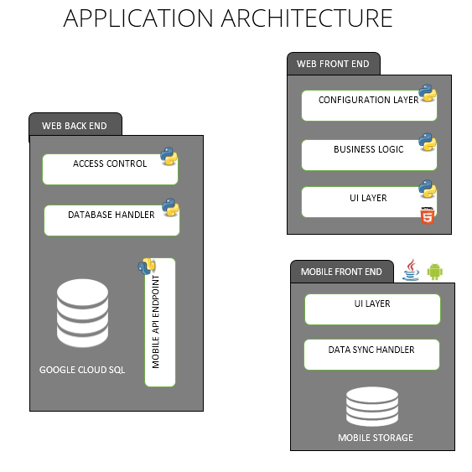

# Components

Each component along with its description, approach, and flexibility is mentioned below.

## Access Control

Access control will work at both module level and data level. Only users authorized to perform functions like data upload, sync, report generation etc. will be able to access the corresponding modules. Likewise at data level, only Project Managers will have access to the data collected and the authorization to modify the data collected by surveyors.

The module will be have the flexibility to introduce additional authorizations without needing other modules to be changed.

## Database Handler

The amount of data collected will scale up with each survey that is added. Google Cloud SQL services are flexible (most of the features can be changed via coding interface) and scalable (any amount of data can be handled). However the database querying mechanism at application end also needs to efficiently request for data retrieval/updating to ensure lower turnaround times for data enabled functionalities.

## Web UI Layer

This will be an interactive Web user interface with role based access with each role having its own functionalities associated with it. The UI layer will be build using technologies including HTML5, CSS3, JQuery, and Angular JS, thus providing a new level of intuitiveness and responsiveness for the end user.

## Mobile Back-End /Mobile API Endpoint

This will be pluggable module running in the web back-end providing REST-full API’s to the Mobile front End. It will allow the Mobile Users to sync data with the server securely and also receive updates. The application will have features such as GPS logging and photo capturing enabled to increase the comprehensiveness of the survey.

## Data Sync Handler

This layer will use the Mobile API Endpoint to sync data to the server and access data from the same. The data access will be secured and will require a user token with every API request. User will be able to access only the data which user token is authorized for.

## Mobile UI Layer

This will be the mobile interface layer with interactive and responsive User Interfaces to allow the surveyor to conveniently access different parts of the survey. Features such as automatic data sync schedule will be enabled to make the entire process streamlined and requiring minimum manual intervention. The UI/UX structure will be created such that it works across different versions of the Android Platform to allow for consistency in survey data collection.

# USE-CASE DIAGRAM

The use case illustrates the various modules identified at current stage and the different users in the hierarchy who would be interacting with them.

Users

Admin

The admin will have the overall administrative privileges of the application. He will exclusively have the authority to add and modify surveys, add new users to the application and change user permissions.

Researcher

Researcher will be at the top of hierarchy and will have access to all the survey data collected across geographies. He/she will have the rights to assign survey to Project Managers at country level and view/modify survey data across geographies.

Project Manager

Project Managers will be assigned at country level and will have the authority to assign surveys to Surveyors. He/she can also view/modify survey data at country level.

Data Editor

Data Editor will be assigned country wise by the Project Manager. Data Editor will have access to the survey data collected by the Surveyors in their respective country. He/she will verify the data collected and flag a question if data is found inconsistent. The flagged surveys will be sent back to the Surveyor who will get an error notification on his/her device informing about the same. The surveyor is expected to revisit the business to verify the data collected. Once the data has been recollected, Data Editor will get a notification regarding the same and only once he/she approves will the survey be considered complete and the error notification on Surveyor’s device disappear.

Surveyor

The Surveyor will have access to the Mobile application only. He/she will undertake surveys collect data which will be stored locally. The data will be synced up to cloud database on gaining access to internet connection. The surveyor will also be responsible for verification/recollection of data if a survey is flagged by Data Editor as inaccurate/incomplete.

Entrepreneur

Entrepreneur’s profile will be created by default when their information is entered by the Surveyor. The Entrepreneur can then access his profile and view simple reports generated from the survey data.

The Entrepreneurs will also be able to receive SMS from the Managers and respond to them. The responses will be saved in the cloud database and they will receive a summarized report based on their responses via SMS. They will also be able to access the web application to view report on the data collected from their business and run basic analytics on the same.

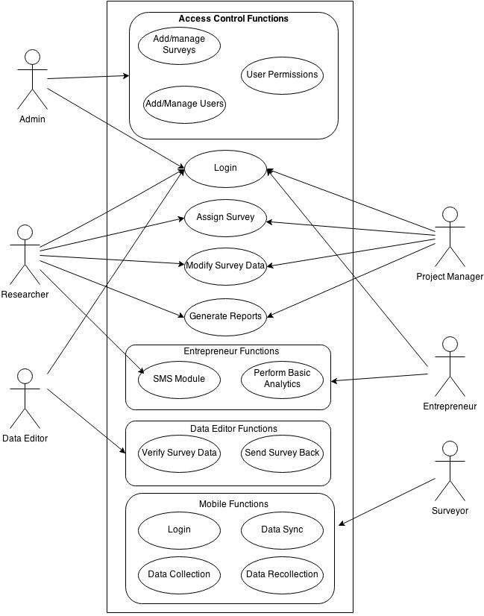

Functionality

Login – Both web and mobile application will be login enabled to make sure only authorized users can get access to the respective applications. The access control feature will ensure that each user gets to view only their respective functionalities after login.

Add/Manage Survey – Only the Admin will have access to this functionality. He will have the authority to modify the survey questions or introduce a new skip logic.

Add/manage Users – This functionality will allow the Admin to add new users for each role. These users on addition will be assigned a unique user id which they can use to gain access to the web/mobile application. Admin will also have the authorization to remove a user.

User Permissions – This functionality will allow admin to modify the permissions that each user has to different modules of the application.

Assign Survey – The Researcher and Project Manager will have access to this functionality. Researcher can assign a survey to the Project Manager at country level. Similarly, the Project Manager will be able to assign the survey to Surveyors.

Modify Survey Data – Researcher and Project Manager will be able to modify the survey data collected by the surveyors in case of any discrepancies in the data. While Project Managers will be able to modify the data at a country level, Researchers will have authorization to modify data across the countries.

Generate Reports – Both Researcher and Project Manager will be able to generate reports based on the surveys conducted.

View Survey Data – The Data Editor will have access to this functionality. He/she will be able to view the data and raise flags if they find the data collected to be incomplete/inconsistent. Data Editor will also be able to check the errors that are still pending for a Surveyor. He/she will also get a list of corrected responses from the Surveyor that they must approve.

Send Survey back – The Data Editor after flagging the survey can send it back to the Surveyor. The flagged surveys will be synced into the local database of the Surveyor who will then have to revisit the business to verify/complete the data.

Perform Basic Analytics – This functionality is exclusively available for an Entrepreneur. He/she will be able to view reports on the data collected from his/her business. He can also perform basic analytics on the data and save the reports in the desired format.

SMS Module – The SMS module will enable the Researcher/Project Manager to send SMSes to selected Entrepreneurs. The Entrepreneurs are then expected to revert back with figures relevant to their business. If the Entrepreneur doesn’t revert back within a pre-defined time frame, they will be sent a reminder and in such cases will not be sent the next SMS in the sequence. The application will then generate a report that will be sent to the Entrepreneurs. A detailed report on the same will be available on the web application as well.   
We will also provide an option to upload spreadsheet in csv/xlsx format with unique IDs of the entrepreneurs. This will enable the Researcher/Project Manager to send messages to selected Entrepreneurs on whom they have performed some analysis offline.

Data Collection – This feature will be available to the mobile application only. The Surveyor is supposed to collect the data from different businesses. The data will be stored locally and will be synced up to the cloud database as and when an internet connection is found.

Data Syncing – This feature will be available to the mobile application only. The application will sync up the locally stored survey data to the cloud database as and when an internet connection is available. The data sync will also download the surveys flagged for verification/completion by the Data Editor.

Data Recollection – This feature will be available to the mobile application only. The Surveyor will be expected to revisit the business for the flagged surveys and verify/complete the survey data.

Challenges

* The bulk SMS functionality for Researcher will be subject to the SMS service provider’s terms and conditions. The cost for sending messages will be as per the service provider chosen and will be additional to the project cost.

# Support & Services

InnovAccer will perform the task of support and maintenance on the dashboard it has delivered to JPAL.

InnovAccer will share a client account on a web based portal. The client can log into the private platform and enter their request/ bug on the platform. A dedicated Engagement manager (EM) from InnovAccer will assess the request. Basis the assessment, the EM will designate the request as *Ongoing* or *Fresh*.

## Ongoing Support

The following services will be provided by InnovAccer through ***Six months*** (Included) from the date of delivery

* First-Time Installation and Training to JPAL staff
* Support on the scope of work and functionality agreed in the current document
* Ongoing Support limited to lesser than 20 hours per month of resource time
* On Call Support: 10 AM – 7 PM EAT on call support
* Online Support: 24*7

## Fresh Support

Any new requirement which is beyond the scope of the given document will be notified to the client and will be treated on a log of hour basis. The billing rate for the resources have been shared with the client

# Staffing

Here is a list of people who will be involved in the project. Attached in the proposal docket are curriculum vitae of each of these individuals.

|  |  |
| --- | --- |
| **Title** | **Role** |
| Project Manager | All Tasks |
| Business Analyst | Framing & Documentation; Business Logic Definition |
| Software Developer | Configuration Layer; Mobile API Endpoint; Business Logic Implementation; Data Handler; Integration; Delivery |
| Mobile Developer | Mobile UI Layer; Integration |
| UI Engineer | Web UI Layer; Mobile UI Layer |
| Test Engineer | Testing |

# Timelines

|  |  |  |  |  |  |  |  |  |  |  |  |
| --- | --- | --- | --- | --- | --- | --- | --- | --- | --- | --- | --- |
|  | **Days** | **Week 1** | **Week 2** | **Week 3** | **Week 4** | **Week 5** | **Week 6** | **Week 7** | **Week 8** | **Week 9** | **Week 10 Onwards** |
| Mobile UI Layer | 7 |  |  |  |  |  |  |  |  |  |  |
| Web UI Layer | 10 |  |  |  |  |  |  |  |  |  |  |
| Web Business Logic | 20 |  |  |  |  |  |  |  |  |  |  |
| ***Design Samples*** | 1 |  |  |  |  |  |  |  |  |  |  |
| Mobile Back-End /Mobile API Endpoint | 10 |  |  |  |  |  |  |  |  |  |  |
| Access Control | 6 |  |  |  |  |  |  |  |  |  |  |
| Database Handler | 6 |  |  |  |  |  |  |  |  |  |  |
| Configuration Layer | 4 |  |  |  |  |  |  |  |  |  |  |
| Data Sync Handler | 6 |  |  |  |  |  |  |  |  |  |  |
| Integration | 5 |  |  |  |  |  |  |  |  |  |  |
| Testing | 6 |  |  |  |  |  |  |  |  |  |  |
| ***Delivery*** | 1 |  |  |  |  |  |  |  |  |  |  |
| Support |  |  |  |  |  |  |  |  |  |  |  |

# Few Examples of InnovAccer designed intuitive platforms and dashboards

